SIMPLE SOLVER Overview

Design and analysis of Boolean equations and state machines is often an extremely complex and time consuming task. Even when a solution is found it can be very difficult to analyze or modify manually.
Simple Solver provides a set of five computer-aided logic design tools:
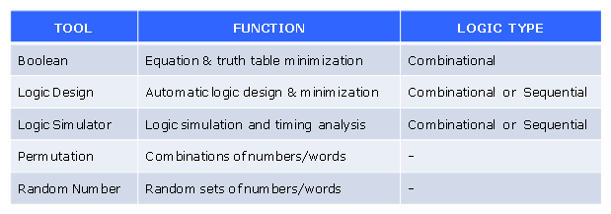
These tools are based on years of engineering design experience, and are designed for both educational and industrial purposes.

The Simple Solver objective is to provide tools that are:
Very easy to use
Educational for both new and experienced engineers
Capable of real digital hardware/software design and analysis

Help menu, Tutorial
In addition to the below descriptions, be sure to run the interactive Simple Solver tutorial. The slides are compatible with Microsoft PowerPoint 97-2007.

1. The Boolean Equation-Truth Table function minimizes and inverts Boolean equations, and generates truth tables for one or a series of Boolean equations. Operator formats are supported for a variety of languages including: ABEL, C, C++, PALASM, VB, Verilog and VHDL. Starting with Version 2.3, it will also accept truth table inputs.

Boolean minimization uses a Karnaugh map approach, also known as a Veitch diagram, K-map, or KV-map. The Boolean Equation software follows the Quine-McCluskey algorithm to implement Karnaugh mapping.

2. The Logic Design function provides automatic design and simulation of digital logic and state machines from truth table or waveform inputs. All logic types and configurations are supported: Combinational, Sequential, Synchronous and Asynchronous. It performs automated logic synthesis by searching for circuits that provide the transfer function specified by the input and output signal waveforms. In general, the first circuit solution found will be the simplest possible solution.
Refer to US Patent 6253365.

3. The Logic Simulator function provides simulation of a user-specified digital logic circuit. It uses the same simulator as the Logic Design tool and will support all circuit types: Combinational, Sequential, Synchronous and Asynchronous. It can be used to evaluate both circuit functions and timing problems such as flip-flop setup and hold times, race conditions and glitches/spikes.

4. The Permutation generator calculates permutations of numbers for a specified number of digits and width. It can be used to gain an appreciation of how rapidly (exponentially) the number of choices in a design grows when, for example, a 2-input AND is added. It also illustrates the value of adding constraints, such as sorting, to reduce the number of possible permutations. It can be used for a variety of applications such as generating binary, octal, hexadecimal or decimal number tables. Includes name mapping.

5. The Random Number generator produces random sequences of numbers in the range of -9999 to 9999. It can be used for many purposes: shuffling 52 numbers (like a deck of cards), randomly selecting a subset of operations for sample testing, and so forth. Includes name mapping. Refer to www.RANDOM.ORG for additional information and other random number generators.

Refer to Table 1 below for a comparison of Boolean vs. Logic Design minimization.

Help
Read the Help section (Ctrl H) of each function for additional information.

Feedback
SSolver users are encouraged to report problems, and to suggest improvements or additional features. Based on this feedback SSolver will be continuously revised and improved.

Send comments to SimpleSolver support at SimpleSolver@nycap.rr.com.

Table 1 – Boolean vs. Synthesis Minimization

